OCF Small Groups: passionately pursuing God, healthy relationships with each other, and people who don’t know Jesus, as part of an intimate group living this life of faith together.
Be Anxious for Nothing
-PART TWO-
The Battle For The Mind

- Read Romans 12:2 and 8:6. Pastor Joe began his message with the following claim: “WHO I THINK I AM determines WHAT I DO and HOW I FEEL.” Has this been true in your life? If so, how?

- Pastor Joe discussed 3 Basic Human Needs.
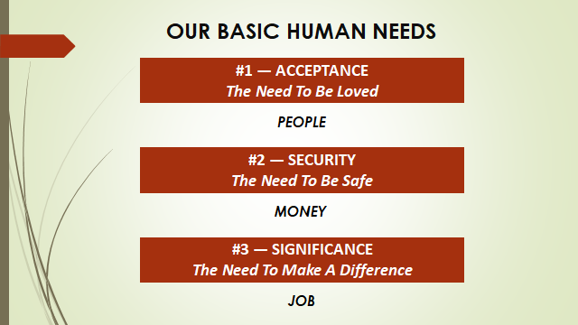

Which of the three seems to be most important for you?

- Leaving God out of the picture for the moment, what are some legitimate ways we try to meet our needs for Acceptance, Security, and Significance through People, Money, and our Job?

- What are some unhealthy ways we try to meet our basic human needs through People, Money, and our Job? Try to provide an example from each of the three categories.

- Talk about the gender distinctions found in the slide below. To what degree are these distinctions true? Try to provide examples.
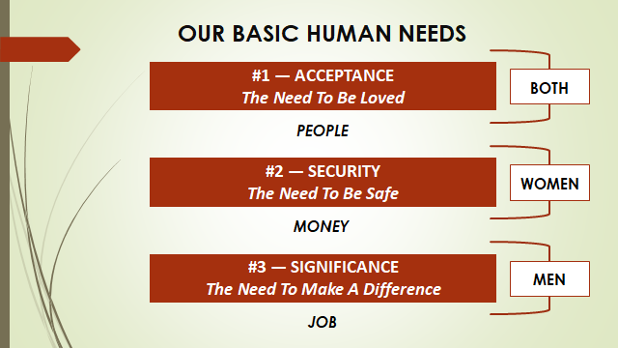

- Which of God’s three provisions for our basic needs has been most meaningful to you and why?
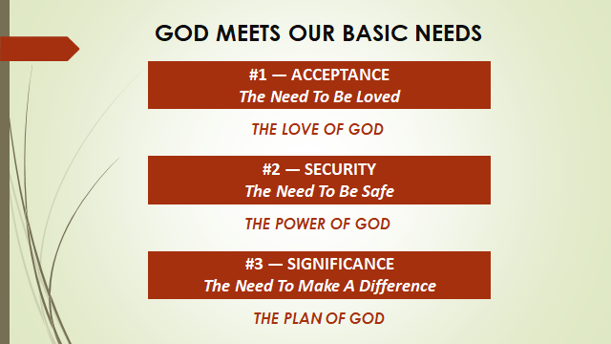

- Which of God’s three provisions for our basic needs have you had the most trouble tapping into and why?

- Pastor Joe demonstrated from Ephesians that “The enemy’s primary strategy in the life of the believer is to try to convince us that what God had done for us in Christ is not true.” What practical steps can we take to win the battle for our identity in Christ?

- Memorize Galatians 2:20 this week
I have been crucified with Christ. It is no longer I who live, but Christ who lives in me. And the life I now live in the flesh I live by faith in the Son of God, who loved me and gave himself for me.

